**Compute Resources**

Training and deploying a model from a notebook running in a Compute Instance

So far, the Managed Services for Azure Machine Learning lesson has covered **compute instance** and the benefits it provides through its fully managed environment containing everything you need to run Azure Machine Learning.

The compute instance provides a comprehensive set of a capabilities that you can use directly within a python notebook or python code including:

* Creating a **Workspace** that acts as the root object to organize all artifacts and resources used by Azure Machine Learning.
* Creating **Experiments** in your Workspace that capture versions of the trained model along with any desired model performance telemetry. Each time you train a model and evaluate its results, you can capture that run (model and telemetry) within an Experiment.
* Creating **Compute** resources that can be used to scale out model training, so that while your notebook may be running in a lightweight container in Azure Notebooks, your model training can actually occur on a powerful cluster that can provide large amounts of memory, CPU or GPU.
* Using **Automated Machine Learning (AutoML)** to automatically train multiple versions of a model using a mix of different ways to prepare the data and different algorithms and hyperparameters (algorithm settings) in search of the model that performs best according to a performance metric that you specify.
* Packaging a Docker **Image** that contains everything your trained model needs for scoring (prediction) in order to run as a web service.
* Deploying your Image to either Azure Kubernetes or Azure Container Instances, effectively hosting the **Web Service**.

**Overview**

In this lab, you start with a model that was trained using Automated Machine Learning. Learn how to use the Azure ML Python SDK to register, package, and deploy the trained model to Azure Container Instances (ACI) as a scoring web service. Finally, test the deployed model (1) by make direct calls on service object, (2) by calling the service end point (Scoring URI) over http.

Exercise 1: Run the Notebook for this Lab

1. In [Azure portal](https://portal.azure.com/), open the available machine learning workspace.
2. Select **Launch now** under the **Try the new Azure Machine Learning studio** message.

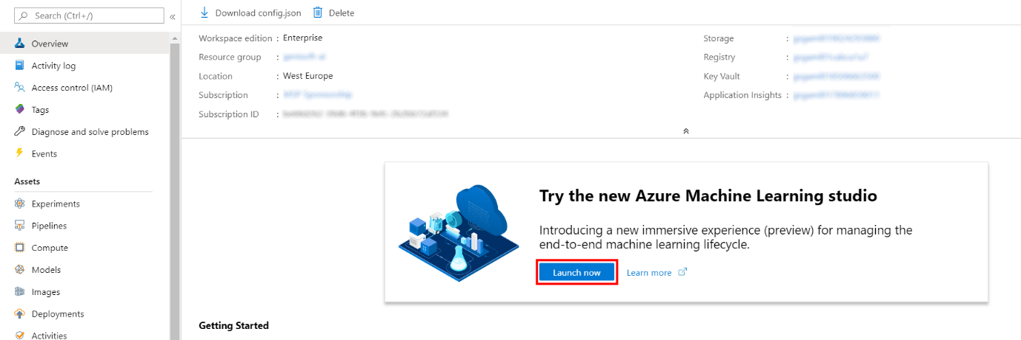

1. When you first launch the studio, you may need to set the directory and subscription. If so, you will see this screen:

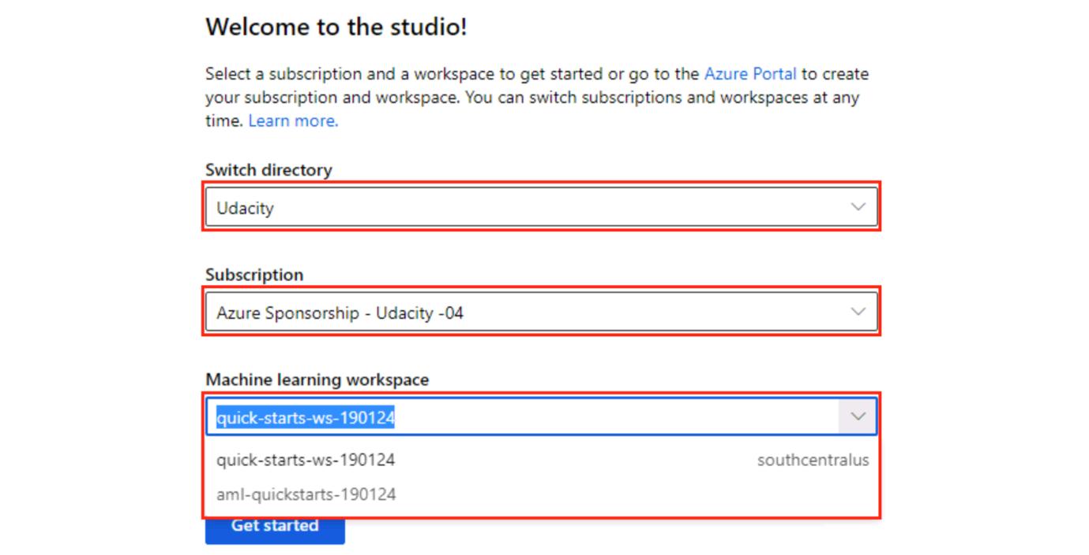

For the directory, select **Udacity** and for the subscription, select **Azure Sponsorship**. For the machine learning workspace, you may see multiple options listed. **Select any of these** (it doesn’t matter which) and then click **Get started**.

1. From the studio, navigate to **Compute**. Next, for the available Compute Instance, under Application URI select Jupyter. Be sure to select Jupyter and not JupterLab.

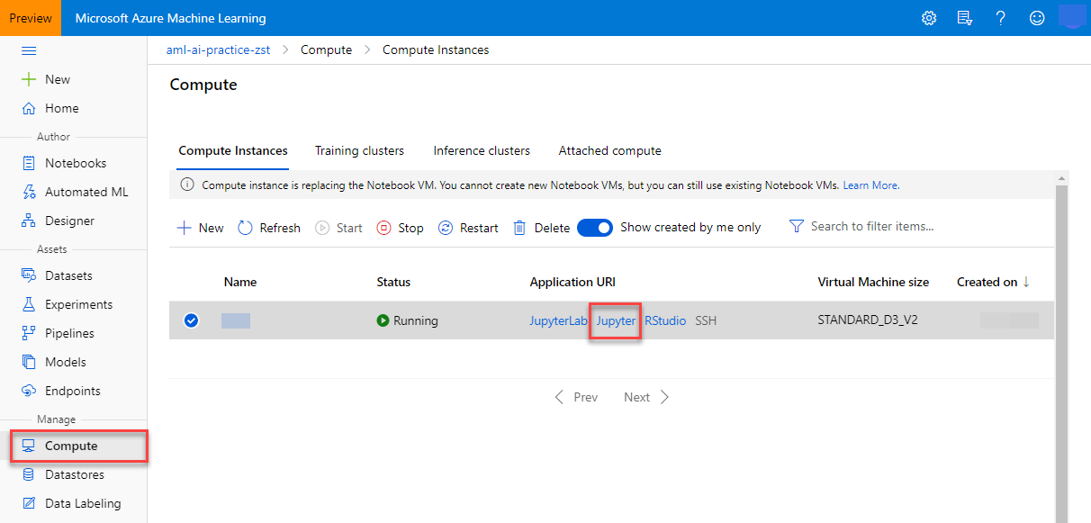

1. From within the Jupyter interface, select **New, Terminal**.

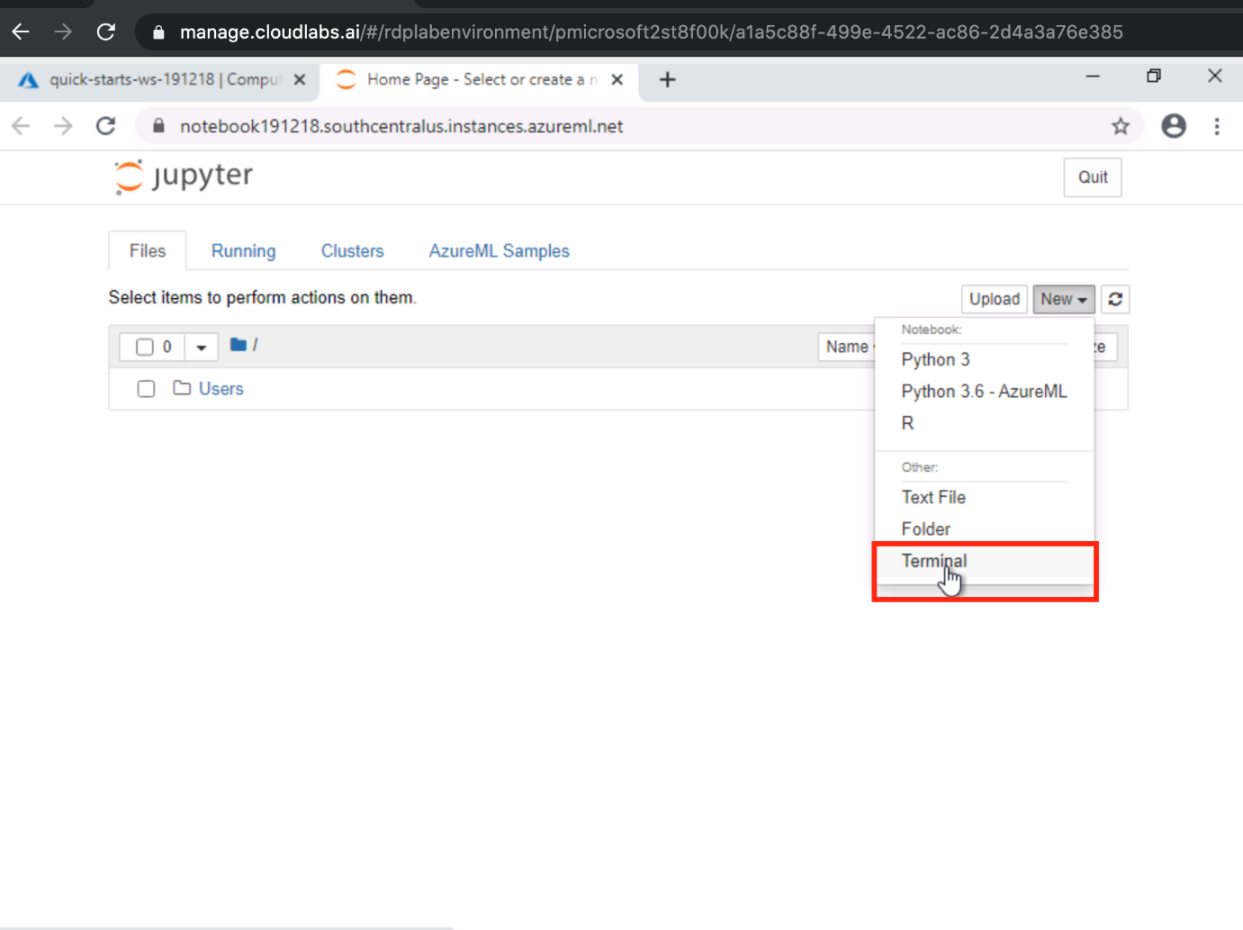

1. In the new terminal window run the following command and wait for it to finish:

git clone https://github.com/solliancenet/udacity-intro-to-ml-labs.git

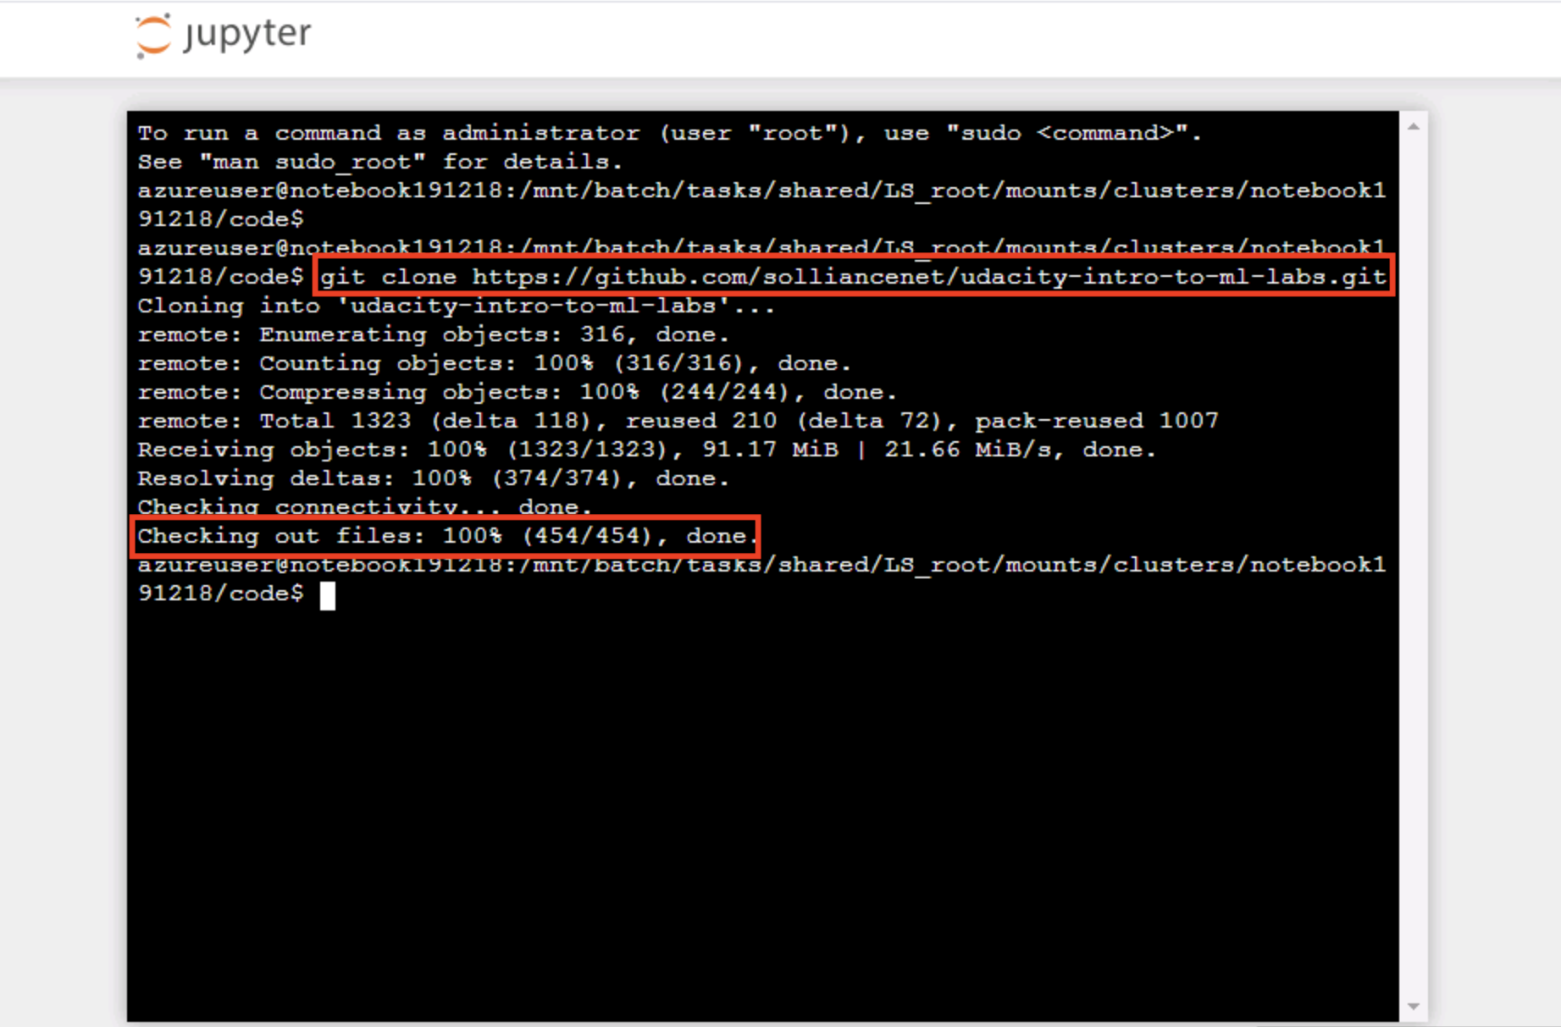

1. From within the Jupyter interface, navigate to directory udacity-intro-to-ml-labs/aml-visual-interface/lab-22/notebook and open deployment-with-AML.ipynb. This is the Python notebook you will step through executing in this lab.

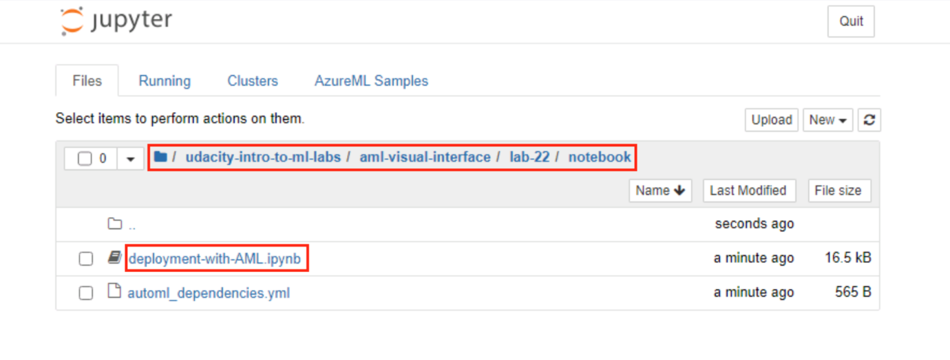

1. In the Setup portion of the notebook, you will be asked to provide values for subscription_id, resource_group, workspace_name, and workspace_region. To find these, open your Azure Machine Learning workspace in the Azure portal and copy the values as shown:

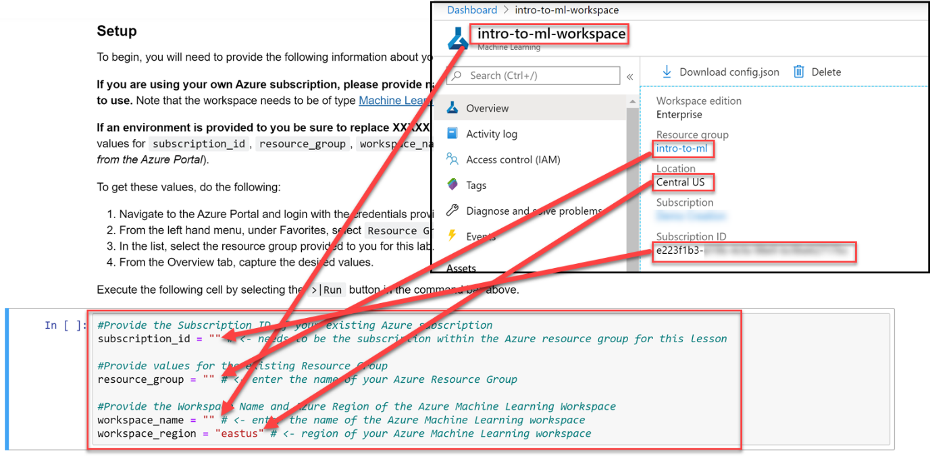

1. Follow the instructions within the notebook to complete the lab.

**Next Steps**

Congratulations! You have just learned how to use the Jupyter application on a compute instance to deploy a trained model to Azure Container Instances (ACI) for real-time inferencing. You can now return to the Udacity portal to continue with the lesson.

